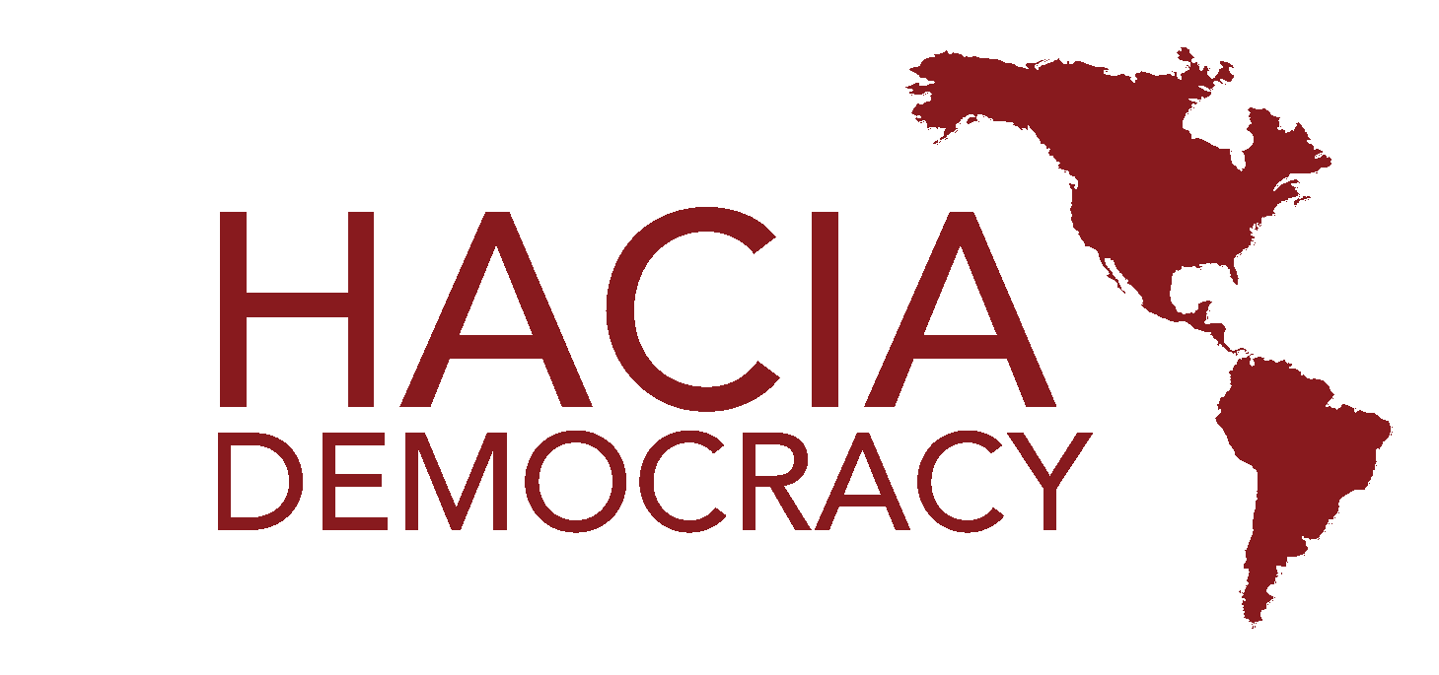
Staffer Application
Harvard Association Cultivating Inter-American Democracy

WHAT IS HACIA?
HACIA Democracy will be having its Twenty-Eighth Summit of the Organization of American States for high school students from across the Americas in a yet-to-be-revealed Latin American city in March 2023. Around 600 delegates and faculty advisors gather annually in different countries around Latin America to attend HACIA, one of the most prestigious conferences in the region. This conference is run entirely by Harvard undergraduates. As of now, we plan HACIA XXVIII to conduct the entirety of its operations in an in-person setting!

As a staff member, you are responsible for overseeing one of the most important aspects of the delegate experience at HACIA—committees—in addition to assisting with administrative responsibilities and, most importantly, enjoying both pre-conference and post-conference activities with the rest of the staff.

The total payment for HACIA staff is $300 in installments. Financial concerns should not be a barrier to participation. If this represents a concern to you, please contact the President, Millán González-Bueno, at president@hacia-democracy.org. All your information will, of course, be treated with utmost confidentiality.

WHAT DO I DO?
As a staff member you have two responsibilities: serving as a Co-Chair, designing and running a committee at conference, and acting as an Executive Assistant for one of the four administrative organs.

As a Co-Chair: you will come up with a committee topic in collaboration with your Committee Program Director, research and write a 25-page double-spaced bulletin on your committee topic over the summer, attend 3 parliamentary procedure trainings, read delegates’ position papers, and communicate with delegates pre-conference. At conference, you will be expected to moderate, lead and guide a committee of 20-50 students as they work towards resolving your topic issue in collaboration with another Harvard Co-Chair and, in some cases, high school students serving as Junior Co-Chairs.

As an Assistant Director: you will be assigned to one of the following four Directors. You will be expected to fulfill 2 hours a week in office hours or other responsibilities.
- Business: negotiating with the hotel & conference center, managing the finances and assets of the organization, and helping with comptrolling.
- Recruiting: registering delegates, communicating with faculty advisors, and recruiting new schools.
- Administration: preparing conference materials (badges, placards, etc.), preparing multimedia, designing the website, maintaining an active social media presence, and helping with committee assignments.
- Development: planning the post-conference trip, booking flights, planning pre-conference social events, developing financial aid and diversity programs, researching grants and sponsorships, and assisting on any special projects or miscellaneous tasks.

But that’s not all! As a staff member, you will be fully integrated into the HACIA community with 2-3 general meetings per semester and regular staff social and bonding events. Then, after the three-day conference, the whole team travels to an amazing destination during the next week to enjoy a fully paid-for post-conference.

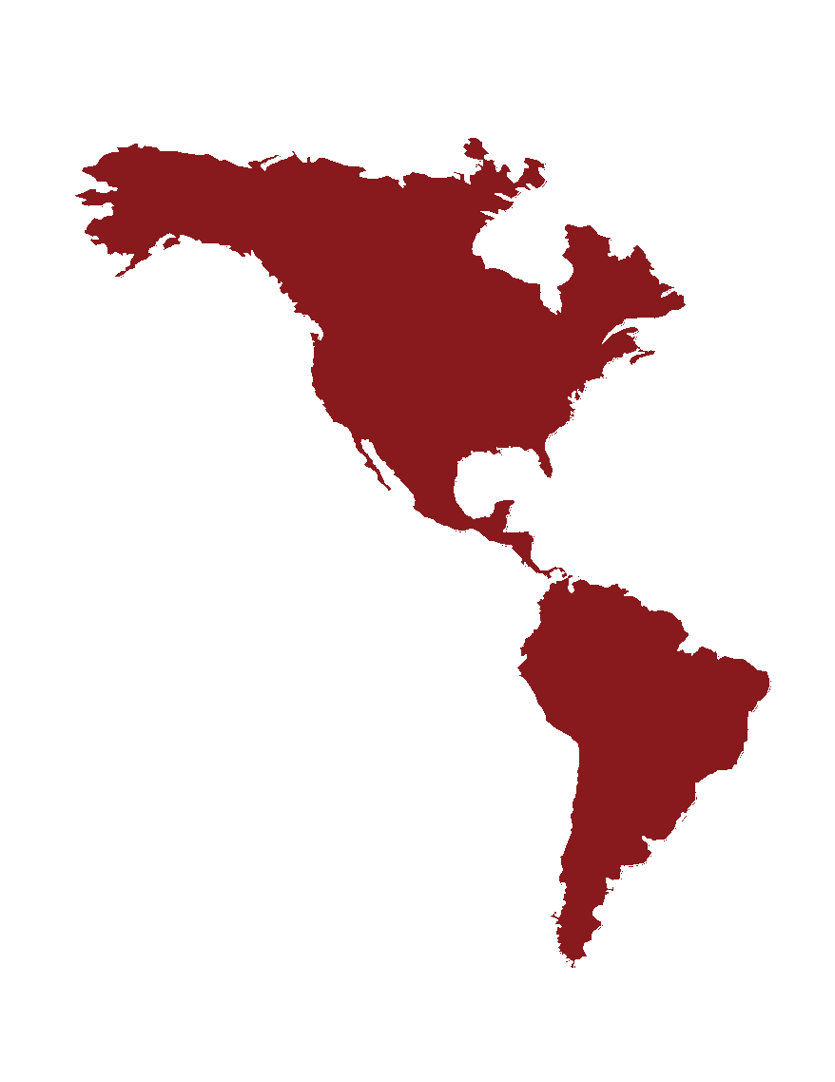
HACIA DEMOCRACY 2023 STAFFER APPLICATION

Please submit this application via email to applications@hacia-democracy.org with a copy of your résumé and a writing sample by 11:59pm on SUNDAY, APRIL 24th 2022. Please include your name in the subject line of the email under the subject “Name, Co-Chair application”.

After a first screening of your application, you will receive an email by or before April 25th notifying whether we are able to offer an interview! Interviews will take place in the week from April 25th - May 1st. A Calendly with all available interview slots will be sent alongside your further consideration notification.

If you anticipate not being able to make any of these interview times, or have any questions or concerns about the application process, please email applications@hacia-democracy.org as soon as possible.

Should you have any questions, concerns, or simply want to learn more about HACIA, please join us during Board Office Hours on Tuesday, April 19th via Zoom (https://harvard.zoom.us/j/96664148721)

Lastly, join us at our information session Friday, April 22th from 5:30 - 6:30 PM at Sever Hall 110.

HACIA delante and best of luck,
The HACIA XXVIII Board of Directors

______________________________________________________________________________
PERSONAL INFORMATION

Name:
Year:
Phone:
Email:
Concentration:
Hometown:
Location (tentative or confirmed) over the summer:

How did you hear about HACIA?

Rate your proficiency in Spanish from none to native. Note that knowledge of Spanish is not a prerequisite for admission.

______ None
______ Beginner
______ Intermediate (Spanish 50 or equivalent)
______ Advanced (Spanish 70 or equivalent)
______ Native

Rate your proficiency in Portuguese from none to native. Note that knowledge of Portuguese is not a prerequisite for admission.
______ None
______ Beginner
______ Intermediate (Portuguese 50 or equivalent)
______ Advanced (Portuguese 70 or equivalent)
______ Native

COMMITTEE PREFERENCES
Please rank your top 4-5 committee preferences below. For a detailed explanation of this past year’s committees, visit our website for both English Committees, Spanish Committees, and Portuguese Committees. The following is a list of all the anticipated committees at HACIA XXVIII, but the list is only tentative.

Please rank based on your interests, but keep in mind that while we will try our best to accommodate everyone, we cannot guarantee any specific committee assignments and you will be considered even for the committees you do not rank.

English Committees

______ OAS Special Mission
Designed as a flexible, ad hoc committee, the Special Mission supports the OAS member states in the prevention, management, and settlement of conflicts. Generally, the special mission targets immediate and pressing political and stability concerns. Therefore, it is often more focused on current events than other committees.
Examples of past topics: OAS Special Mission to Venezuela, OAS Special Mission to Mexico (1994)

______ Inter-American Court of Human Rights
The ICHR is the primary human rights protection system of the OAS, serving to uphold and promote basic rights and freedoms in the Americas. Because of this, the ICHR often faces some of the most controversial social issues of all the committees.
Examples of past cases: single-parent adoption, same-sex marriage, abortion, state violence in Venezuela

______ Community of Latin American and Caribbean States
Designed as a wholly Latin American counterpart to the (occasionally U.S.-dominated) OAS, CELAC generally focuses on issues that are more critical towards the U.S., including the Cuban embargo and the legal status of coca in Bolivia.
Examples of past topics: brain drain in Latin America, intelligence collaboration

______ Pan American Health Organization
The PAHO serves a dual role as both the regional sub-unit of the World Health Organization and as the primary health policy organization of the Inter-American System. Topics faced by the PAHO generally pertain to immediate and long-term public health issues, disease control, and the development of international public health campaigns.
Examples of past topics: medical drug development, Zika, mental health treatment

______ Crisis Cabinet
Unlike the other committees, the Crisis Cabinet simulates an executive cabinet within a single Latin American country, focusing primarily on crisis response rather than legislation. The Crisis Cabinet is generally the most fast-paced and multi-faceted. Because it is a smaller committee, it is run by only one chair. Previous experience in a model crisis setting is highly encouraged. Because of the nature of the committee, the bulletin is longer (approximately 30 pages).
Examples of past cabinets: Executive Cabinet of President Cristina Kirchner, Colombian Peace Negotiations (2012)

______ Legislature of the Host Country
Depending on the host country of HACIA XXV, the Legislative committee will focus on domestic political issues within that country and simulate the legislative process. Previous experience in a model legislative setting is highly encouraged. Because of the nature of the committee, the bulletin is longer (approximately 30 pages).
Examples of past topics: female representation in the Chilean Senate, education reform and income inequality

______ Historical committee
This committee will be a re-creation of a historical crisis situation. Previous historical committees have included the Panamanian Executive Cabinet in 1974 and the Venezuelan Executive Cabinet during the 2002 coup. Because it is a smaller committee, it is run by only one chair. Previous experience in a model crisis setting is highly encouraged. Because of the nature of the committee, the bulletin is longer (approximately 30 pages).
Example of past cabinets: Cabinet of Panama (1974), Cabinet of Brazil (1937)

______ Permanent Council of the OAS
This committee works to maintain peaceful relations between members of the OAS. It discusses solutions to problems that have international ramifications. The OAS Permanent Council has the broadest mandate of any HACIA committee, and often serves as an introductory committee for first-time delegates.
Example of past topics: press freedom, the regulation of social threats

Spanish Committees

______ Cumbre de las Américas
Este comité es una reunión de jefes de estado que discute soluciones para los problemas de la región. Directores pueden escoger cuales temas la cumbre va a discutir. Como este es un comité personalístico, los delegados tendrán personajes de los jefes de estados de varios países.
Ejemplos de temas: recursos naturales para el desarrollo regional, combatiendo el clientelismo

______ Consejo de Seguridad de las Naciones Unidas
Este consejo tiene el cargo de mantener la paz y la seguridad internacional en el mundo entero. Quince países hacen parte de este consejo, incluyendo a cinco miembros permanentes quienes tienen poder de veto, los Estados Unidos, Rusia, China, el Reino Unido y Francia.
Ejemplo de temas: la situación en Sudán del Sur

______ Corte Interamericana de Derechos Humanos
Esta corte tiene la responsabilidad de proteger los derechos humanos de los habitantes de las Américas. Esta corte ve casos en los cuales el estado está siendo culpado de violar los derechos humanos de sus ciudadanos.
Ejemplos de casos: familias Brasileñas desplazadas, vendedores ambulantes, Ayotzinapa en Mexico

______ Gabinete de Crisis
Este es un gabinete histórico ejecutivo basado en un país de Latino América. En vez de enfocarse en aprobar legislación, el comité se enfoca en responder a crisis que ocurren en el país. Generalmente, el gabinete de crisis es uno de los comités que se desarrolla rápidamente y que se ocupa con cuestiones multifacéticas. Como tiende a ser un comité pequeño, generalmente se requiere un solo director. Experiencia previa en un comité de crisis es aconsejable.
Ejemplos de gabinetes: Gabinete de Colombia (2012), Junta Suprema Central de España (1812)

______ Comité Histórico
Este es un comité histórico basado en un país de América Latina. El comité se enfoca en alguna cuestión real que tuvo gran relevancia en el pasado. Un gran conocimiento acerca del tema discutido es necesario.
Ejemplos de gabinetes: Leyes de Reforma, Mexico (1861)

______ UNASUR:
La Unión de Naciones Suramericanas, UNASUR, es una organización internacional que tiene como objetivo la integración regional en materia de energía, educación, salud, ambiente, infraestructura, seguridad y democracia.
Ejemplos de temas: independencia económica de Latinoamérica, medidas de Respuesta a las Insurgencias, corrupción en Latinoamérica

Comitê Português

______ Corte Interamericana de Direitos Humanos.
A CIDH é o principal sistema de proteção dos direitos humanos da OEA, servindo para defender e promover os direitos e liberdades básicos nas Américas. Por causa disso, o CIDH freqüentemente enfrenta algumas das questões sociais mais controversas de todos os comitês.
Exemplos de casos anteriores: adoção por pai solteiro, casamento do mesmo sexo, aborto, violência estatal na Venezuela

______ Comitê histórico.
Este comitê será uma recriação de uma situação de crise histórica. Comitês históricos anteriores incluíram o Gabinete Executivo do Panamá em 1974 e o Gabinete Executivo da Venezuela durante o golpe de 2002. Por ser um comitê menor, é dirigido por apenas um presidente. Experiência anterior em um cenário de crise modelo altamente encorajada. Devido à natureza do comitê, o boletim é mais longo (aproximadamente 30 páginas).
Exemplo de gabinetes anteriores: Gabinete do Panamá (1974), Gabinete do Brasil (1937)

______ Crisis Cabinet
This is a historical Crisis Cabinet based on the government of a Latin American country. Instead of focusing on legislation, the Crisis Cabinet responds to ongoing and novel crises the country faces in a predetermined time period. Usually, Crisis Cabinets are incredibly fast-paced committees that require both delegates’ and chairs’ utmost attention and rapid response. Because of its smaller size, Crisis Cabinets are usually led by a single Co-Chair with the assistance of a Junior Co-Chair
Crisi Cabinet examples : Colombian Peace (2012), Supreme Central Junta of Spain (1812)

Other Staff Roles:
______ Director of Press Corps and NGOs* †
Press Corps is a unique position that incorporates public relations and committee oversight. Before the conference, the Director of Press Corps and NGOs will assist the Director of Administration with managing the conference’s online presence, including social media outreach, website design, and content production for fundraising and recruiting. During the conference, the Director will chair the Press Corps and NGOs Program, a committee tasked with simulating the international press, NGOs, and other Third Party Actors. The delegates of the Press Corps and NGOs Program will also be responsible for documenting conference happenings and producing The Delegate, our online and print newspaper.

______ Pitch us a committee idea:
Have an idea for a committee that you don’t see above? Pitch a new committee to us below in 100 words in the language that you wish to run it! We are looking for innovative committees centered on Latin American issues that will make for conducive debate amongst high school students.

ADMINISTRATIVE PREFERENCES
As an HACIA staffer, you will be expected to serve as an Executive Assistant for approximately 2 hours a week during the Fall and Spring semester.

Please rank your administrative Assistant Director preferences below.

______ Business
- Negotiating with the hotel & conference center
- Managing the finances and assets of the organization
- Helping with comptrolling
- Finding partnerships and grants.

______ Recruiting
- Registering delegates
- Communicating with faculty advisors
- Recruiting new schools
- Developing financial aid and diversity programs
______ Administration
- Preparing conference materials (badges, placards, flags, etc)
- Preparing multimedia
- Designing the website
- Maintaining social media
- Helping with committee assignments.
______ Development
- Planning the post-conference trip
- Booking flights
- Planning pre-conference social events

SHORT RESPONSE
- Please answer the following questions.
- If you are a native or fluent Spanish speaker and would be interested in leading a committee in Spanish, please answer three of the questions in Spanish.
- If you are a native or fluent Portuguese speaker and would be interested in leading a committee in Portuguese, please answer three of the questions in Portuguese.
- While we urge you to choose Spanish if you feel comfortable in the language, please know that successful co-chairing of such committees requires near-native fluency. If you opt for Spanish or Portuguese, your interview will be bilingual.

1. As a potential co-chair, please describe your committee preferences and outline a detailed plan for your first two committee choices, including potential topics. (>400 words)

2. Please briefly describe your past international experiences (one academic and one work-related), especially those pertaining to Latin America (if applicable). (250 words)

3a. As an assistant director, which skills would you bring to the organization (i.e. experience in conference administration, coding and technology skills, etc.)? Please explain your administrative preferences, in light of your skills and personal interests. (200 words)

3b. In particular, are you familiar with any of the following tools/languages?
____ InDesign
____ Wordpress
____ JavaScript/HTML
____ Quickbooks

4. Please describe an experience in which you have acted as a teacher, tutor, or mentor (this could also include informal experience, like helping a friend in a class!). What have you learned about being an effective teacher from this experience? (200 words)

5. Describe your primary extracurricular activities and list in detail your time commitments (confirmed or tentative) for the next 12 months. Please be sure to include your summer plans and Internet availability.
Please understand that reliability and Internet access during the summer—particularly around writing the bulletins—is absolutely essential in all cases.

6. What is your motivation for applying to HACIA 2023? What will you gain from partaking in HACIA and what can you contribute to the conference? (250 words)

WRITING SAMPLE

Please attach a writing sample to your application email titled “Name, HACIA Writing Sample”. Choose a 3 to 10-page academic or professional piece of work (ideally written for a previous conference, like H(N)MUN or HMC) that you have already written previously. This should be reflective of your writing style. If possible, please choose one in the language to which you are applying.

If you are applying for the position of Director of Press Corps and NGOs, please include a sample of graphic design, creative work, photography, or anything else that demonstrates the experience you would bring to the role.

